Objective :-

Owner of **Madhav Store** wants us to help them create a dashboard to track and analyze their online sales across India.

Project Key Points

* Data Collection
* Data Cleaning & wrangling
* Data Modeling
* Data Visualization
* Dashboard Design

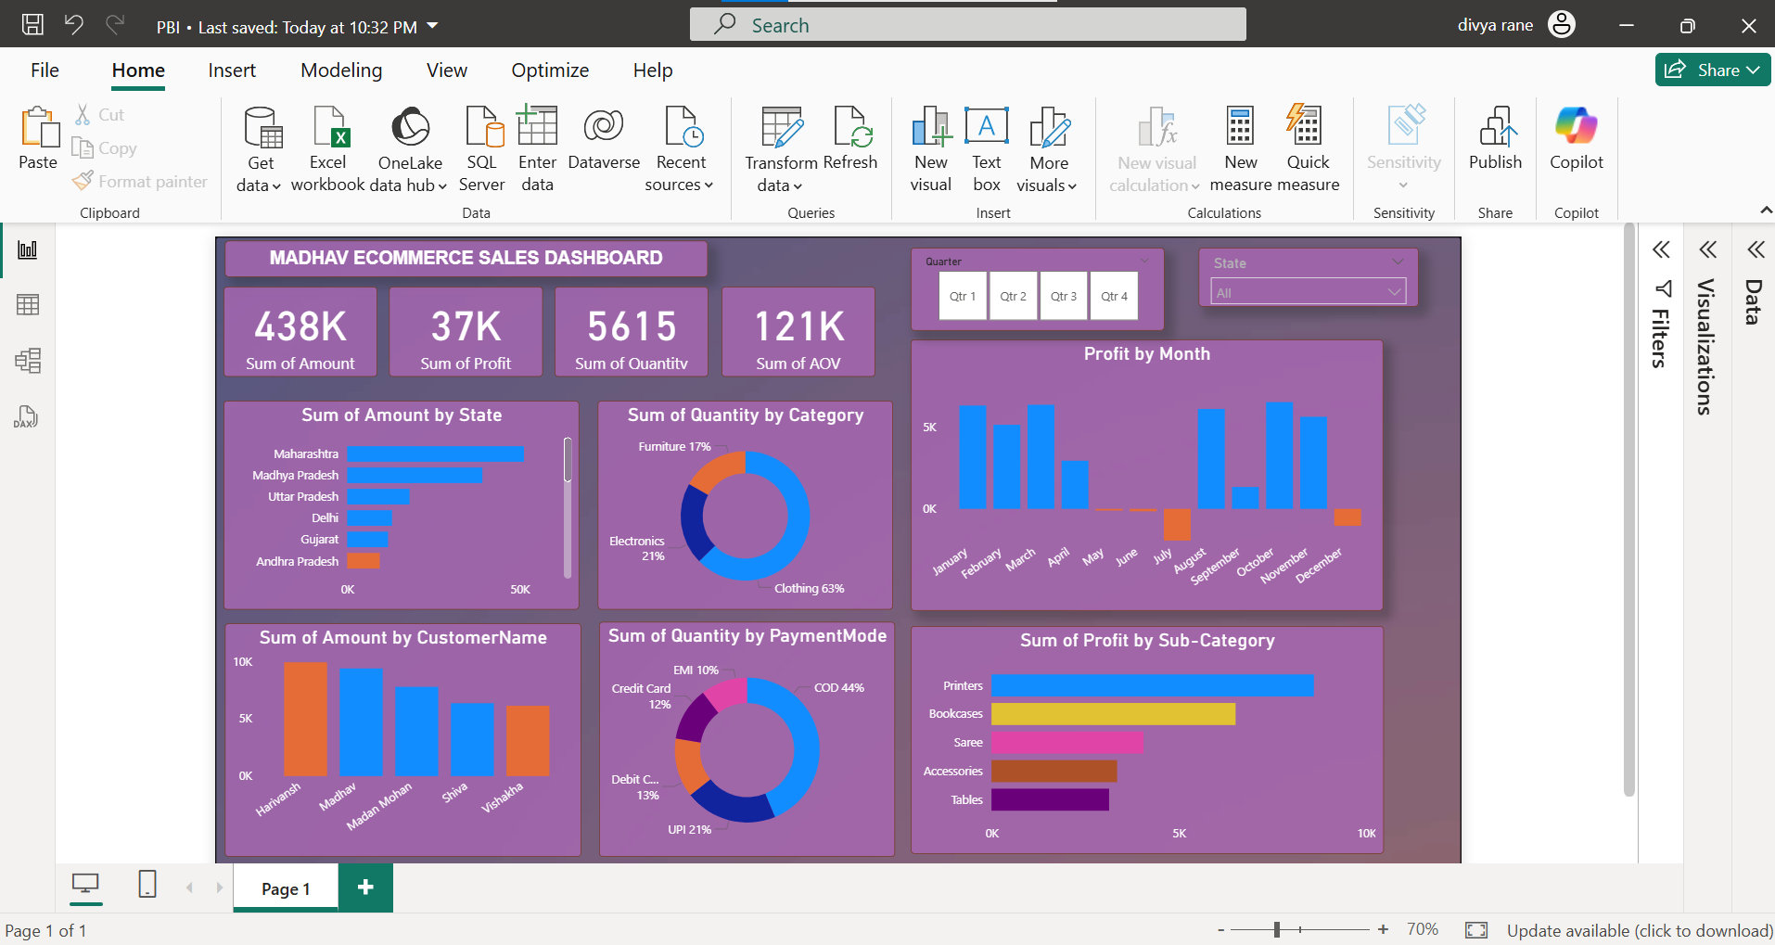

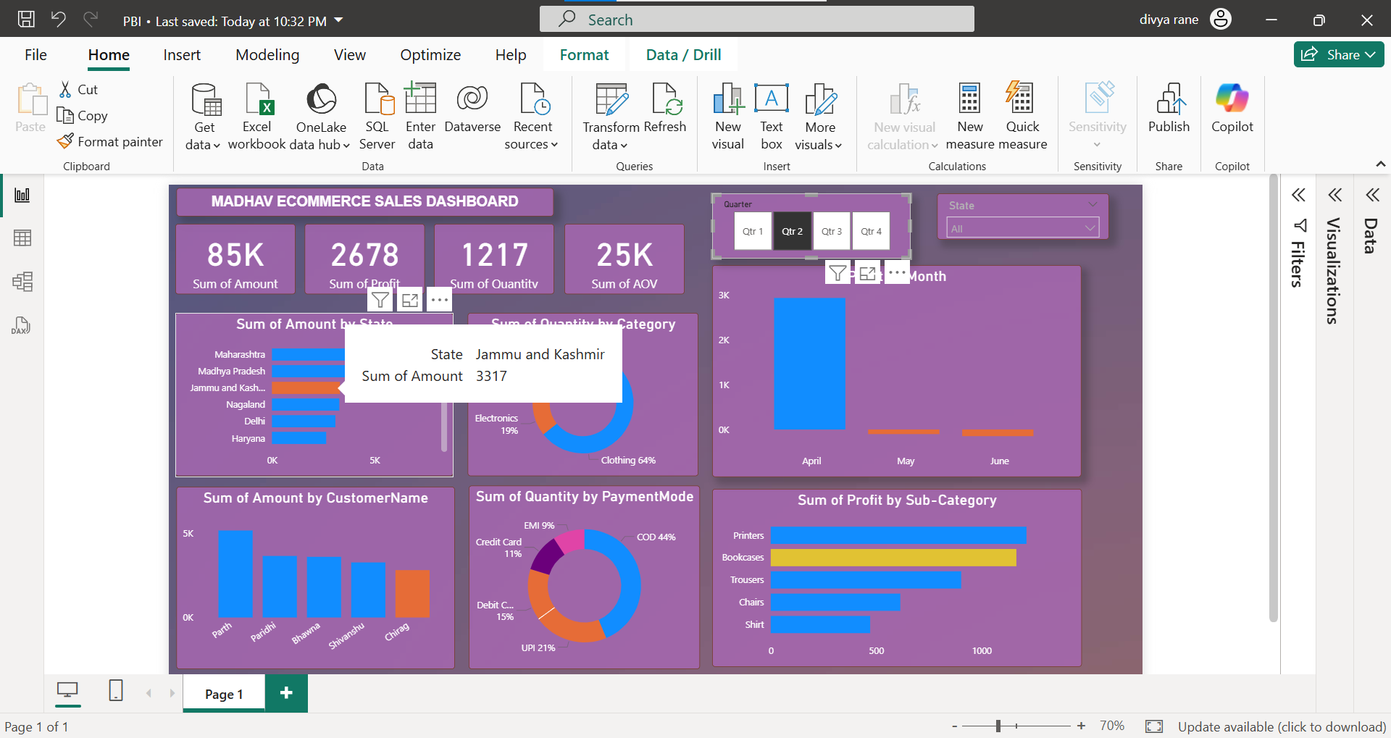

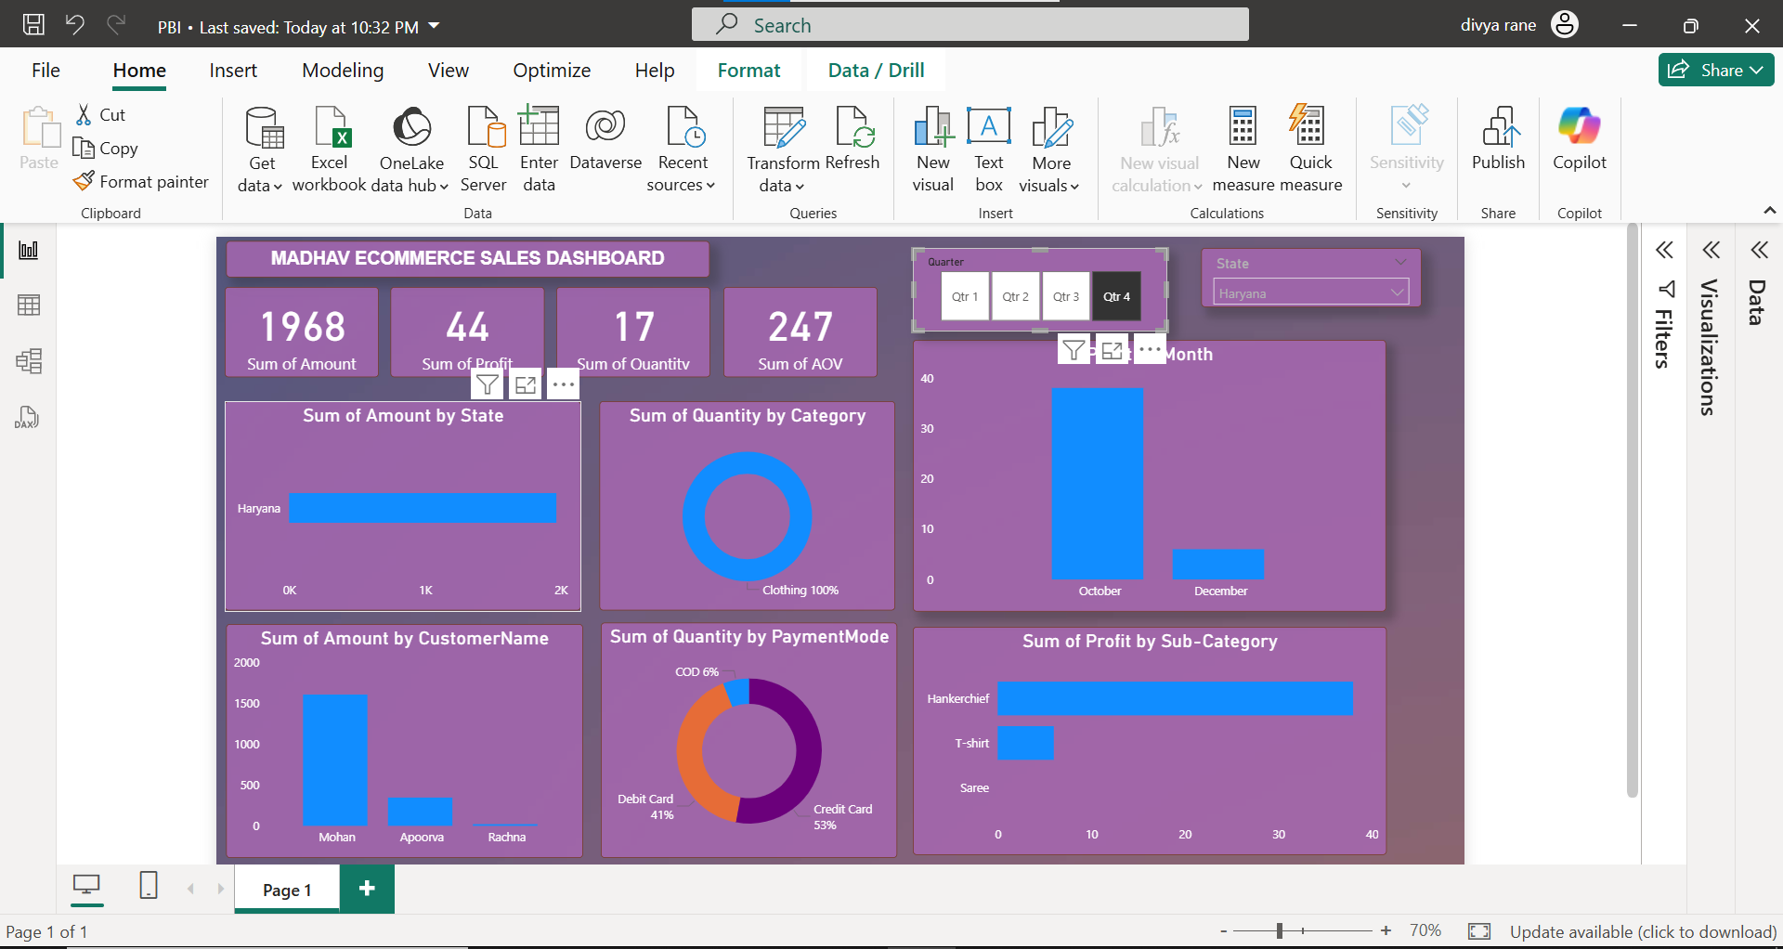

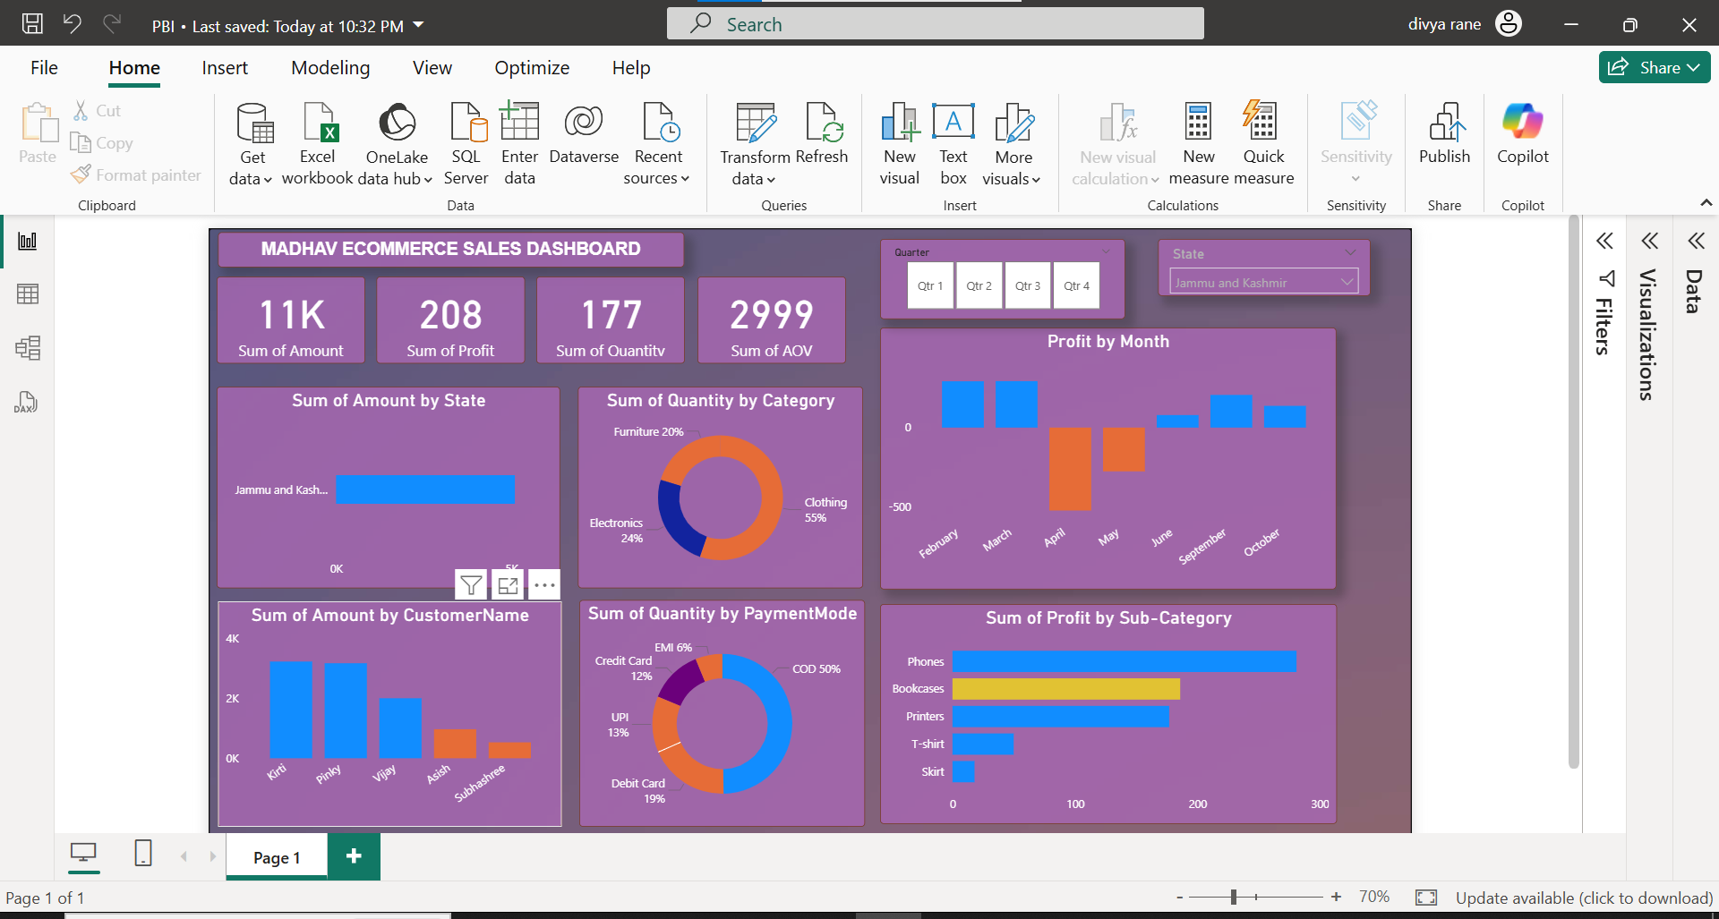

Project Learnings :-

* Created interactive dashboard to track and analyze online sales data.
* Used complex parameters to drill down in the worksheet and customizations using filters and slicers.
* Created connections , join new tables , calculations to manipulate data and enable user driven parameters for visualizations
* Used different types of customized visualization (bar chart , pie chart, donut chart, clustered bar chart, scatter chart, line chart , area chart , map , slicers , etc.)